Ontology of Aging
Barry Smith
Draft: July 24, 2014

By ages I mean youth, the prime of life, and old age.
(Aristotle, Rhetoric, Book II, Chapter 12)

… one man in his time plays many parts,
His acts being seven ages. At first the infant,
Mewling and puking in the nurse's arms.
Then, the whining school-boy with his satchel
And shining morning face, creeping like a snail
Unwillingly to school. And then the lover,
Sighing like furnace, with a woeful ballad
Made to his mistress’ eyebrow. Then, a soldier,
Full of strange oaths, and bearded like the pard,
Jealous in honour, sudden, and quick in quarrel,
Seeking the bubble reputation
Even in the cannon's mouth. And then, the justice,
In fair round belly, with a good capon lin'd,
With eyes severe, and beard of formal cut,
Full of wise saws, and modern instances,
And so he plays his part. The sixth age shifts
Into the lean and slipper'd pantaloon,
With spectacles on nose and pouch on side,
His youthful hose, well sav'd, a world too wide
For his shrunk shank, and his big manly voice,
Turning again toward childish treble, pipes
And whistles in his sound. Last scene of all,
That ends this strange eventful history,
Is second childishness and mere oblivion,
Sans teeth, sans eyes, sans taste, sans everything. (As You Like It, Act 2, Scene 7)

Abstract: We will argue that a theory of aging, if it is to do justice to the distinction between (what might be called) ‘natural’ and premature aging, must rest on an associated theory of life stages. We will outline an approach to aging in these terms. and consider the issues which arise when the idea of an aging stage in the life of human beings is considered from an evolutionary point of view.
In some notes appended at the end we consider the question of whether aging is a disease, paying special attention to the Boorse’s definition of disease as a state of statistically species-subnormal biological part-function.

Introduction
We begin by distinguishing two senses of ‘aging’: 1. aging in the sense of getting older, which happens to everything that persists through time, and 2. ‘aging’ in the narrower sense that is studied by gerontobiologists, aging as a set of processes marked by behavioral and cognitive decline, typically occurring at the end of the life of an organism. It is aging in the latter sense that will concern us here.
In human beings aging has been shown to be associated with certain characteristic biological processes (the ‘hallmarks of aging’ – López-Otín et al., 2013), including genomic instability, telomere attrition, deregulated nutrient-sensing, stem cell exhaustion, and altered intercellular communication at the molecular and cellular levels of bodily organization. We will mean by ‘the aging process’ the sum total of all aging-relevant processes occurring in an organism during which aging is occurring, including both molecular and cellular processes and cognitive and behavioral processes.
When so conceived, the set of aging processes in human beings are a good candidate for forming a natural. There are scientific laws governing such aging processes, laws identified by and studied in multiple distinct disciplines, and analogous processes and laws have been studied experimentally in mouse and other organisms serving as models for human biological phenomena.
Like all biological natural kinds, the natural kind aging process manifests both typical cases and also a penumbra of different sorts of borderline cases, the most important of which for our purposes here being cases of what is standardly called ‘premature’ aging. The latter is distinguished not merely by the fact that it occurs at a different stage in the life of the organism, but also by the fact that it involves only some of the characteristic hallmarks of aging.
Aging has a certain relation to the process of dying, which we define, loosely, as the maximal set of processes occurring in an organism in the interval which terminates with the death of the organism, as in Figure 1.
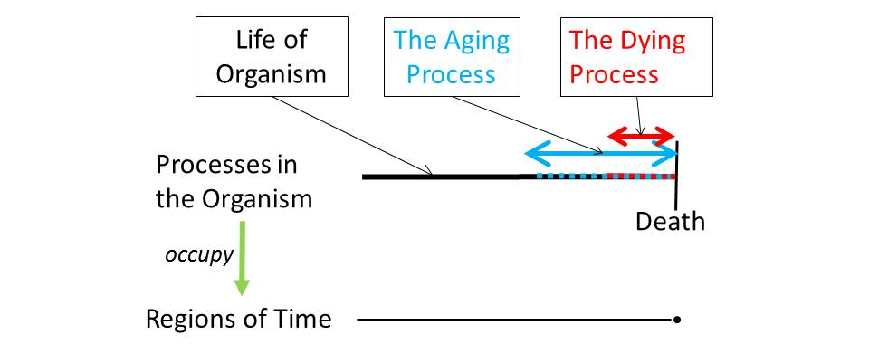
Figure 1: Aging and Dying

When does dying begin?
We can in some cases give a reasonably precise answer as to when the dying process (and, in many cases, aging) ends – by referring to the time of death of the organism in question. Matters are different, however, in relation to the question of when the dying process begins. For this, we can generate a series of answers which become progressively more precise – for instance that dying begins some time after conception, some time after adolescence, some time after early adulthood, and so on. Even these statements may be controversial, however, depending on our understanding of ‘normal.’ My recommendation here is that we do not worry about such questions at all – just as we do not worry about (the precise answer to questions such as): when do people become bald? Is there an exact time when a person with dementia begins to have dementia? To answer such questions in the case of dying (and aging) will (at best) not be easy, and because nothing in what follows will turn on giving a precise answer to such questions we do not address them here.
Figure 1 comprises two levels – of processes on the upper, and intervals and instants of time on the lower level – with relations of occupation connecting the two together. We can formulate a series of axioms governing these relations for the case of dying, as follows:
process of dying occupies temporal interval
process of dying part_of life of organism
life of organism has_part process of dying
life of organism occupies temporal interval
process of dying finishes life of organism
process of dying has_participant organism
and, only slightly less trivially:
for every process p that is part_of life of organism x, if p occupies temporal interval t and x’s process of dying occupies temporal interval t′, then not (t later than t′)
The axioms listed hold universally, in the sense that, for example, every life of an organism has some process of dying as part.
We understand ‘process dying’ in such a way that it includes even the sort of rapidly accelerated dying processes occurring in cases of massive trauma; hence it is trivial not merely that every process of dying is part of some life but also that every life includes some dying. Note, however, that on this reading process of dying is not a natural kind.

The Process of Aging
We can formulate analogous axioms also in relation to the process aging (a term which we use, for the moment, in such a way as to include also cases of premature aging). Thus we can assert quite generally that:
process of aging part_of life of organism

This is because every process of aging is part_of the life of some organism. However, we cannot assert that every life of an organism has included within it some process of aging as part – again, because of cases of major trauma or death through disease in childhood. Dying is in such cases not preceded by any process of aging.

Defining our terms
Our approach to understanding death, dying and indeed disease and other biological phenomena is strongly influenced by the Gene Ontology (GO) (Ashburner, et al., 2000). Briefly, the GO is a controlled structured vocabulary comprising some 30,000 terms and 4 relations (is_a or is-subtype-of, part_of , has_part, and regulates). These terms are used by biologists to describe the attributes of gene products (roughly: genes and proteins), where by ‘attribute’ is meant the types and subtypes of biological processes, molecular functions, and cellular components with which given genes and proteins are associated. The GO correspondingly consists of three sub-ontologies – or ‘controlled vocabularies’ – hierarchically organized in terms of the subtype relation, representing the types and subtypes of biological processes, molecular functions, and cellular components respectively. Each of these vocabularies is used by curators of experimental data and literature to codify for example that given genes or proteins are associated with specific types of response to light stimulus, or glucose binding, or plasma membrane.
Terms in the GO are designed to reflect the usage of biologists. The ontology thereby provides a means of computationally associating humanly intelligible descriptions of biological phenomena with the massive quantities of sequence data being made available through genomic experimentation. Because the GO is species neutral, it provides a means of comparing data pertaining to different organisms in a way that allows results gained through experimentation on non-human organisms to be exploited in information-driven investigations of human health and disease.

Figure 2: Fragments of the GO Hierarchy from http://www.ebi.ac.uk/QuickGo

The GO, and the ontologies that have been created in its wake, provides a highly effective strategy for cross-disciplinary collaboration – including the sort of collaboration required for the study of aging. Because the GO is used to annotate experimental data and standard chemical and biological databases pertaining to the biological phenomena represented by its terms, it can be used to identify correlates of these phenomena – including phenomena associated with aging (in humans and in other species) – at the molecular level. (See examples supplied by the amigo Gene Ontology browser in Figure 3 below.)
Premature aging
As we saw, while every instance of aging is a part of the life of some organism, not every instance of the life of an organism has as part some instance of aging. This is first of all because some organisms’ lives are cut short by early death. In other words, they die but they never age. But it is secondly because it may be that a process of aging occurs that does not have death as its terminal boundary because the process in question is premature and is followed by a process of rejuvenation.
When Shakespeare, following an older tradition, talks of the ages of man, then he is assuming that there are certain natural phases in the life of the (human organism) during which, in the natural course of things, processes of certain types – including the aging process – take place. Only on the basis of such an assumption, I submit, can we understand phrases such as premature aging and early death.

Figure 3: Fragments from the list of annotations returned for the queries 'aging' and 'premature senescence' in mouse

This implies however that when we talk about the life of an organism we mean not just: the sum total of processes taking place within the spatiotemporal region occupied by the organism from the beginning to the end of its existence, but also something that is organized – in normal cases – into a natural sequence of stages, beginning with certain natural stages of fetal and embryological development. The latter have an astonishingly precise timing – shared to a very high degree across the species – reflecting the complex chains of dependence of function between successively developing parts. As more and more of the functioning parts of the organism are in place, such dependencies become less sensitive to precise timing; thus later stages may overlap temporally, take more or less time, and occur (to a degree) earlier or later in the life of each organism.
Ontologies have been developed for development stages in a number of species, including ontologies of development stages of single organs, and ontologies of development stages (life cycles) of single cells. Such ontologies have been especially salient for the studies of early development in humans and in model organisms, as for example in the Edinburgh Mouse Atlas Project. The Plant Structure Development Stage Ontology provides an especially detailed representation of development stages across the life of the whole plant and of its anatomical parts, and we shall return to this ontology below. For mature humans, in contrast, we lack similarly high-quality ontology resources for describing developmental stages across the whole life of the organism.

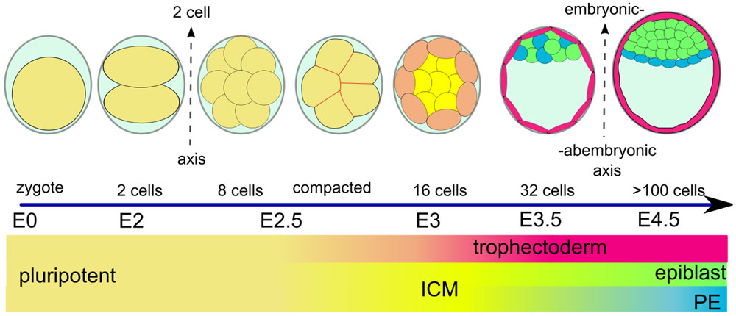
Figure 4: Early Mouse Development (fragment, from Krupinski, et al., 2011)

To talk of age-related causes of the death, for a given human being, now, is to talk about processes which both (1) occur during (what would normally be counted as) the aging stage in the life the human being in question and (2) are like (are of the same kind as) processes which normally occur during aging in the normal life span of a human being. ‘Normal’ in this context does not mean ‘statistically normal’. Rather, it is the kind of normality which Cornelius Rosse, one of the pioneers of contemporary bio-ontology, called ‘canonical’ (Rosse and Mejino, 2003). To see the difference between canonically and statistically normal, consider that canonically, all human beings have 32 teeth. Statistically, however, adults in the US aged 20 to 64 have an average of 24.92 teeth. ‘Canonical anatomy’, for Rosse, signifies the anatomy that is generated by the coordinated expression of the organism’s own structural genes.
Rosse’s Foundational Model of Anatomy Ontology (FMA), still one of the best crafted biomedical ontologies, describes what is referred to by structural anatomists as the Bauplan of the human organism as an assembly of body parts at multiple levels of granularity from molecules up to the whole body. Associated with these body parts are sets of interrelated functions at different levels of granularity.
Canonical anatomy is distinguished on the one hand from variant anatomy, the anatomy of, for example, people whose heart is on the right, or of people with a third nipple; and on the other hand from what is called ‘instantiated anatomy’ – the anatomy of actual human beings, which involves in each case slight or major deviations from canonical anatomy, such as missing teeth, amputation stumps, fractured tibias, glass eyes, and so on. Just as adult human beings share a common Bauplan, so – and for a similar reason – human lives share a common life plan, that is divided canonically into a certain sequence of stages or phases ending in death.
Just as the human Bauplan manifests marvelous regularities at all levels of spatial granularity from (exactly 46) chromosomes (including exactly 2 sex chromosomes) up to (exactly, in adults, 206) bones and (exactly 7) solid organs (heart, lungs, kidneys, spleen, skin), so also the human life plan manifests marvelous regularities at all levels of temporal granularity. Thus there are regularities which manifest themselves from minute to minute and from day to day (as for example the diastole/systole cardiac cycle and the sleep-wake cycle). And also regularities which manifest themselves over longer intervals, including the division of life into (overlapping) stages of prenatal development, growth and maturation, reproduction and aging. A third set of regularities, closely related to the Bauplan and the life plan of the organism, are the regularities in the interrelated sets of functions associated with each of the organism’s parts.
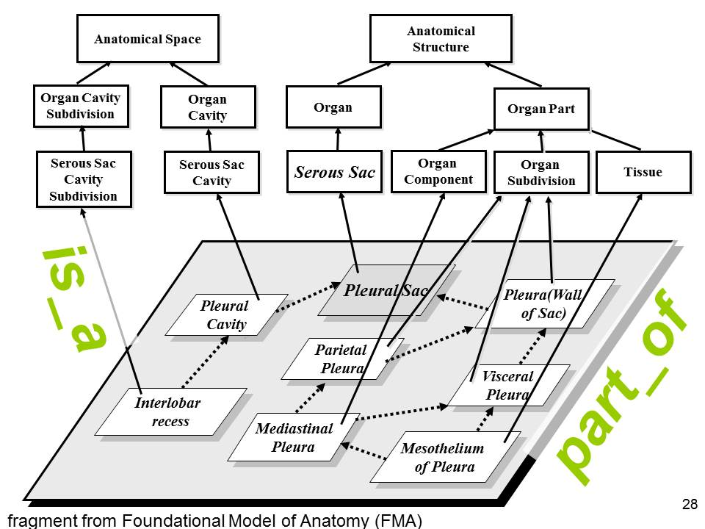
Figure 6: Foundational Model of Anatomy (fragment)
.
Stages in the GO
The Gene Ontology, like the FMA, is a canonical representation. It focuses on what is normal in the realms of the three domains of cellular components, molecular functions, and biological processes – on what happens when genes and proteins function normally in the development of an organism; on what makes aging processes ‘normal’ aging processes; and so on.
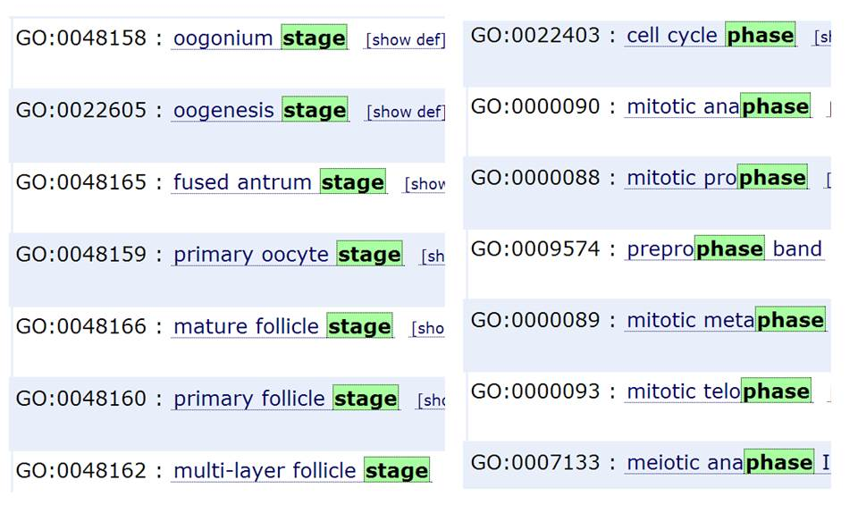
Figure 6: Illustration of the GO's non-unified treatment of stages/phases

Figure 6 lists the primary stage/phase terms in the Gene Ontology. As this list makes clear, the GO has thus far been less than systematic in its treatment of stage phenomena, which it deals with under two headings of (1) stages (such as primary follicle stage) in the development of the ovum, and (2) phases (mitotic phase, miotic phase) in the cell cycle. IN addition the GO has multiple terms formed with the adjective developmental (for example developmental maturation, developmental pigmentation, and so on). The most important such term is developmental process, which is defined by the GO as:
a biological process whose specific outcome is the progression of an integrated living unit from an initial condition to a later condition.
Other developmental terms are typically defined by the GO in terms of ‘developmental process’.
Because the GO does not have the resources to represent stages in the life of the mature organism, certain problems arise. Developmental pigmentation, for example, the GO defines as:
the developmental process that results in the deposition of coloring matter in an organism, tissue, or cell.
Developmental pigmentation is thus for the GO both a kind of pigmentation and a kind of developmental process. Pigmentation itself is defined as:
the deposition of coloring matter.
At the same time the GO asserts that pigmentation during development is a ‘related synonym’ of developmental pigmentation. To distinguish the two it would be necessary for the GO to capture the fact that, to talk of developmental pigmentation in a given organism is to talk of pigmentation processes which not merely (1) occur during the developmental stage in the life of the organism in question but also (2) are like (are of the same type as) those which occur during normal development for an organism of this type.
Adolescent tattoos are outcomes of pigmentation processes of a sort which occur in the developmental phase in the human life cycle, but they are not – in contrast to what happens, for example, in the case of a naturally ripening tomato or of darkening of children’s hair – of the same type as pigmentation processes which occur during normal development for an organism of this type .
Plant Development Stage Ontology
To understand aging, in light of the above, we need a strategy for representing of the canonical stages through which an organism’s life proceeds in which mistakes of this sort are avoided. The Plant Ontology (PO) provides illumination in this respect, not only because its Plant Development Stage Ontology is well-crafted, and not only because the plant domain manifests an elaborate interplay of whole plant and plant part development stages, but also because the PO itself was designed in no small part to support the efforts of plant growers in annotating phenotypic data pertaining to the plant life cycle. (Walls 2012, Cooper 2013)
Stages are not simply blocks of time. And nor are they simply maximal collections of processes occurring within an organism’s life during a specific interval of time (because again not all processes occurring in the reproductive stage of an organism’s life are reproductive processes). Moreover, stages may overlap. Plants can participate in reproductive processes even when they are in their senescent stage. In fact, fruit ripening is a reproductive process in fruit which occurs in the senescent stage in the life of the whole plant.
In the life cycle of plants we have an impressive system of alternating generations between the gametophyte or haploid stage in the life of the whole plan, during which male and female gametes fuse to produce the zygote from which the sporophyte arises; and the sporophyte or diploid stage – which is the dominant form in vascular plants such as ferns – in which the spores are produced from which the gametophyte arises. It is the latter which we normally think of as the life of a plant (since it is the latter, simply put, which is visible above ground).
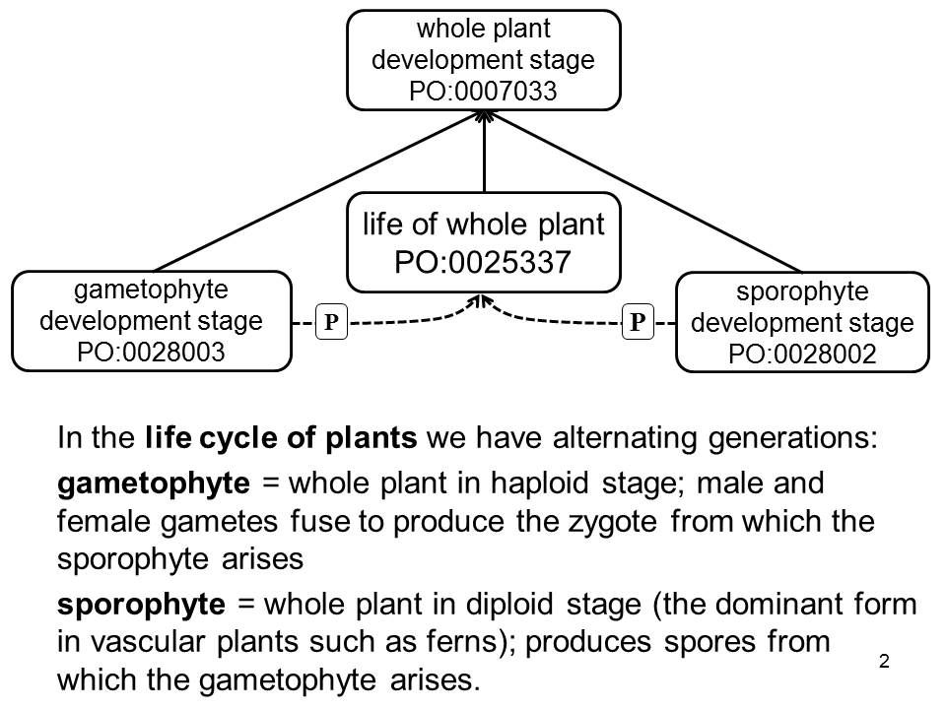
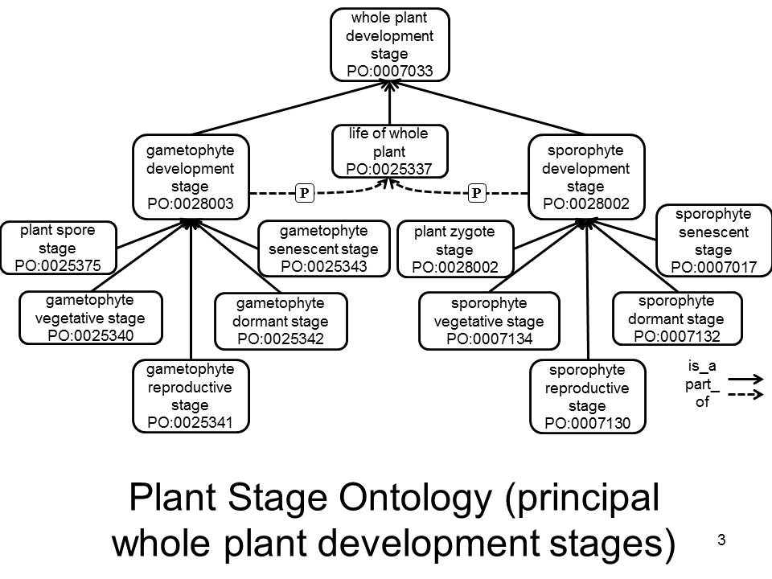
Figure 7: Gametophyte vs. Sphorophyte Stages (from the Plant Ontology)

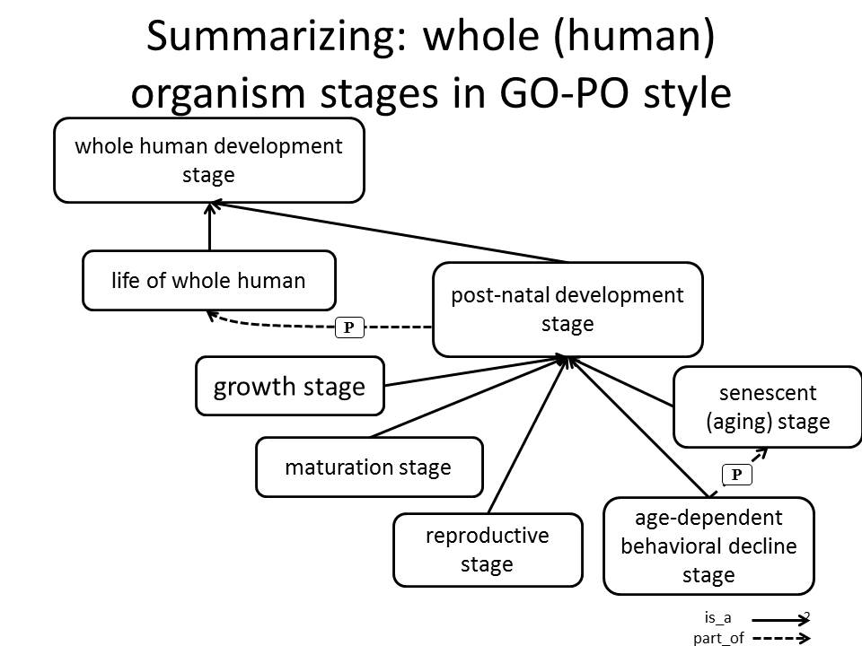
Applying this to humans
human organism development stage
prenatal human development stage
postnatal human development stage
life of human organism

P
P
Figure 9: Stages in the Life of the Human Organism

Preliminary notes on the question: Is aging a disease?
Two questions remain to be addressed:
1. Is there an aging stage in the life(plan) of the human organism
2. Is aging a disease?
Is there an aging stage in the life(plan) of the human organism
One way to justify a positive answer to this question would be to identify that aging is part of the lifeplan for human beings, thus that aging provides some sort of evolutionary contribution to fitness – as contrasted for example with a view of aging as a matter of cumulative damage caused by biological processes, analogous to the wear and tear on your car.
There are a number of hypotheses as to why senescence occurs; for example, some posit it is programmed by gene expression changes, others that it is the cumulative damage caused by biological processes. Whether senescence as a biological process itself can be slowed down, halted or even reversed, is a subject of current scientific speculation and research.
Aging of the whole organism
Organismal senescence is the aging of whole organisms. In general, aging is characterized by the declining ability to respond to stress, increased homeostatic imbalance, and increased risk of aging-associated diseases. Death is the ultimate consequence of aging, though "old age" is not a scientifically recognized cause of death because there is always a specific proximal cause, such as cancer, heart disease, or liver failure. Aging of whole organisms is therefore a complex process that can be defined as "a progressive deterioration of physiological function, an intrinsic age-related process of loss of viability and increase in vulnerability".
Differences in maximum life span among species correspond to different "rates of aging". For example, inherited differences in the rate of aging make a mouse elderly at 3 years and a human elderly at 80 years. These genetic differences affect a variety of physiological processes, including the efficiency of DNA repair, antioxidant enzymes, and rates of free radical production.

Is aging a disease?
Albeit indirectly, senescence is by far the leading cause of death. Of the roughly 150,000 people who die each day across the globe, about two thirds—100,000 per day—die of age-related causes; in industrialized nations, moreover, the proportion is much higher, reaching 90%. Senescence is not the inevitable fate of all organisms, and animal organisms of some groups even experience chronological decrease in mortality, for all or part of their life cycle. On the other extreme are accelerated aging diseases, rare in humans. http://en.wikipedia.org/wiki/Senescence

To view aging as a disease – as for example in the field of rejuvenation research – is to view aging as a condition that can be manipulated, treated and delayed, for instance via drugs designed to treat multiple aging-associated diseases at the same time, or to design strategies (for example involving stem cell replacement) to treat dimensions of bodily change which are currently not acknowledged as diseases at all.
If aging is a disease, then the aging stage is not a canonical stage at all; thus it does not form part of the life plan of the normal human organism. Rather, it is precisely a deviation (or set of deviations) from this plan, which can in principle be rectified by treatment.
Is aging a disease from the Boorsean point of view? In his “Second Rebuttal on Health (2014)”, Boorse defines ‘disease’ as follows:
1. The reference class is a natural class of organisms of uniform functional design; specifically, an age group of a sex of a species. [The reference class would include organisms across multiple generations.]
2. A normal function of a part or process within members of the reference class is a statistically typical contribution by it to their individual survival [or] reproduction.
3. Health in a member of the reference class is normal functional ability: the readiness of each internal part to perform all its normal functions on typical occasions with at least typical efficiency.
4. A disease [later, pathological condition] is a type of internal state which impairs health, i.e., reduces one or more functional abilities below typical efficiency (1977, 562)
Boorse’s reference here to ‘uniform functional design’ corresponds to our proposal, above, to conceive the Bauplan of the human organism as something common to all members of the species, and as amounting to a ‘common functional design’.
The first comment to be made when we attempt to apply this definition of ‘disease’ to the case of aging is: what would the appropriate type of “internal state” be, “which impairs health, i.e., reduces one or more functional abilities below typical efficiency”. Aging itself is a process, not a state. As we age all of the body’s parts (canonically) participate in various processes of senescence. All of the body’s parts can be said to bear the disposition to such processes of senescence. Aging is a process, not a disease; if there is a disease or “pathological condition” involved in aging, then it is not this process which is the disease, but rather the disposition which underlies this process. Aging is the realization of the disposition to age.

Acknowledgements
With thanks to Ramona Walls, Pankaj Jaswal, Laurel Cooper, and Catherine Nolan.

References
Olivier Bodenreider Barry Smith and Anita Burgun, “The Ontology-Epistemology Divide: A Case Study in Medical Terminology”, Achille Varzi and Laure Vieu (eds.), Formal Ontology in Information Systems. Proceedings of the Third International Conference (FOIS 2004), Amsterdam: IOS Press, 2004, 185–195.
Laurel Cooper, Ramona L. Walls, Justin Elser, Maria A. Gandolfo, Dennis W. Stevenson, Barry Smith, Justin Preece, Balaji Athreya, Christopher J. Mungall, Stefan Rensing, Manuel Hiss, Daniel Lang, Ralf Reski, Tanya Z. Berardini, Donghui Li, Eva Huala, Mary Schaeffer, Naama Menda, Elizabeth Arnaud, Rosemary Shrestha, Yukiko Yamazaki, Pankaj Jaiswal, “The Plant Ontology as a Tool for Comparative Plant Anatomy and Genomic Analyses”, Plant and Cell Physiology, 54 (2) (Database Issue), Feb. 2013, 1-23.
Georg Fuellen, Melanie Börries, Hauke Busch, Aubrey de Grey, Udo Hahn, Thomas Hiller, Andreas Hoeflich, Ludger Jansen, Georges E. Janssens, Christoph Kaleta, Anne C. Meinema, Sascha Schäuble, Paul N. Schofield, Barry Smith, Jürgen Sühnel, Julio Vera, Wolfgang Wagner, Eva C. Wonne, Daniel Wuttke, “In-Silico-Approaches and the Role of Ontologies in Aging Research,” Rejuvenation Research, 2013 Dec;16(6):540-6.
Michael Ashburner, Catherine A. Ball, Judith A. Blake, David Botstein, Heather Butler, J. Michael Cherry, Allan P. Davis, Kara Dolinski, Selina S. Dwight, Janna T. Eppig, Midori A. Harris, David P. Hill, Laurie Issel-Tarver, Andrew Kasarskis, Suzanna Lewis, John C. Matese, Joel E. Richardson, Martin Ringwald, Gerald M. Rubin, and Gavin Sherlock, “Gene Ontology: tool for the unification of biology”, Nature Genetics, May 2000; 25(1): 25–29.
Pawel Krupinski, Vijay Chickarmane, Carsten Peterson, “Simulating the mammalian blastocyst – molecular and mechanical interactions pattern the embryo”, PLoS Computational Biology, 2011, 7(5); e1001128.
Carlos López-Otín, Maria A. Blasco, Linda Partridge, Manuel Serranoemail, Guido Kroemer, “The Hallmarks of Aging”, Cell, 153:6 (2013), 1194–1217.
Cornelius Rosse and Jose L. Mejino Jr., “A reference ontology for biomedical informatics: the Foundational Model of Anatomy,” Journal of Biomed Informatics, 2003 Dec;36(6):478-500.
Barry Smith, Werner Ceusters, Bert Klagges, Jacob Köhler, Anand Kumar, Jane Lomax, Chris Mungall, Fabian Neuhaus, Alan Rector and Cornelius Rosse, “Relations in Biomedical Ontologies”, Genome Biology (2005), 6 (5), R46.
Ramona L. Walls, Balaji Athreya, Laurel Cooper, Justin Elser, Maria A. Gandolfo, Pankaj Jaiswal, Christopher J. Mungall, Justin Preece, Stefan Rensing, Barry Smith, Dennis W. Stevenson, “Ontologies as Integrative Tools for Plant Science”, American Journal of Botany, 99(8): 1–13, 2012.

For more details concerning the logic of such relational statements, especially as concerns the difference between parthood as a relation between universals and parthood as a relation between the instances of such universals, see (Smith et al., 2005).
On the proper treatment of ontology terms formed through the use expressions such as ‘during’ and ‘without’ see Bodenreider, et al., 2004.
The Plant Ontology includes two branches: of plant anatomy, and of plant development. The two branches are interconnected in virtue of the fact that there are stages not merely in the development of the whole organism but also in the development of its parts. Cells have stages. Organs have stages. Parts of plants have stages.
For an illustration see https://www.youtube.com/watch?v=BTXkh34BmZs. Here we note that, as for plants so also for humans, there is aging in the whole organism and also aging in the parts of the organism; in plants, especially, these two sets of aging processes need not proceed in tandem. Thus the fruit of the plant may be going through a ripening stage while the plant itself is senescing.
See for example http://www.sens.org/.

